Day 2: Flamin-Go Find It!

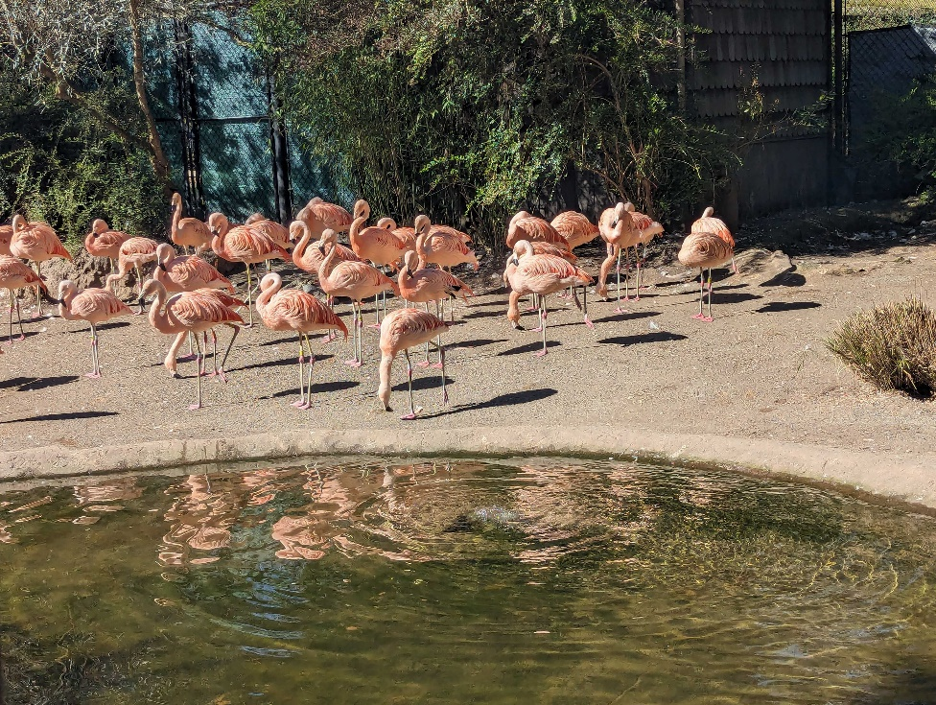

*When Kolina was out and about she snapped this shot of some friendly flamingos. These wading birds are known for their long legs and bright pink plumage, and can be found all around the world. Can you wade through this challenge to find them?*

*What is the name of the area in which you'd find these flamingos?*

Reading this story, about how Kolina was ‘out and about’, gives me the impression that these flamingos were not encountered in a zoo, but more likely somewhere in the wild. However, the picture does show some fence-like structures and an artificial looking pond, which does remind me of a zoo. So, for now I am keeping both options open. I hope to get more information from a Google Reverse Image search. Looking through the results, I find one that shows a fence with a similar layered structure as the one on the right in the picture. It mentions the Woodland Park Zoo. So, I decided to look up this Zoo on Google Maps and look for Street View images of the flamingo sanctuary. I am able to find a picture that again shows a similar fence, but I am not 100% sure. The rain pipe in the photo for the challenge seems to be on the other side than the one in the Google Maps photo. When flipping the challenge photo, the perspective also seems to match better. Still, I am unsure if it is a perfect match, since the Google Maps photo shows an extra fence section directly left of the shed while this is not visible in the challenge photo (see below). I think it is worth a guess. Looking at the website of the Woodland Park Zoo, I can find that the area is called the Temperate Forest. This answer is unfortunately incorrect. Going back to the Google Reverse Image search, I decide to only search the top half of the picture, thus focusing on the fences and part of the flamingoes. One result is from an Instagram account that shows a metal fence with green fabric that looks very similar to our photo for this challenge (see below). The rim of pond also looks very similar. I decide to do a Google Reverse Image search on this photo, which resulting in me finding another very similar photo, with the caption mentioning Woodland Park Zoo (see below). It seems I had the right location all along. Turns out, the correct answer is:

**Woodland Park Zoo**.

